**SWAPPING OF NUMBERS**  
  
**EXP NO: 15**

**AIM:**To compute swapping of numbers using 8085 processor.

**ALGORITHM:**

1. Load a 8-bit number from memory location into accumulator.

2)   Move value of accumulator into register H.

3)   Load a 8-bit number from next memory location into accumulator.

4)  Move value of accumulator into register D.

5)   Exchange both the registers pairs.

6)  Halt  
  
**PROGRAM:**  
  
LDA 2001  
  
  
MOV B,A  
  
  
LDA 2002  
  
  
STA 2001  
  
  
MOV A,B  
  
  
STA 2002  
  
  
HLT

**INPUT:**  
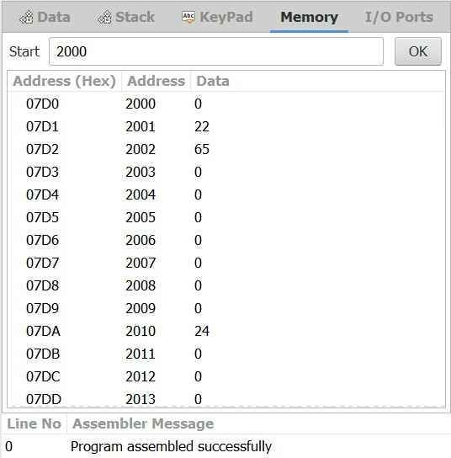  
  
**OUTPUT:**  
  
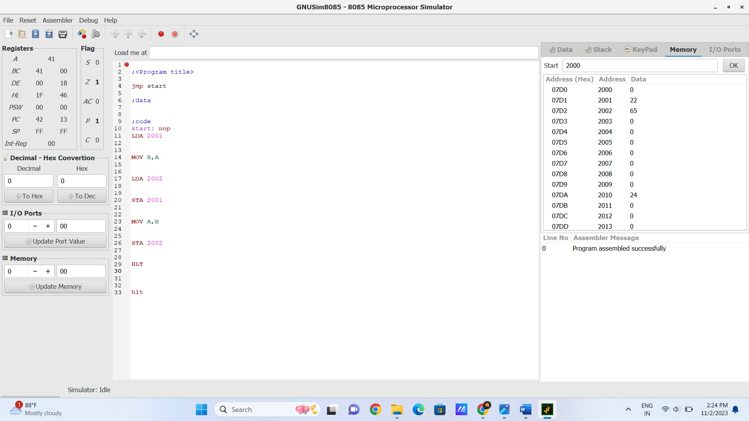  
   
  
  
  
  
  
**RESULT:**Thus the program was executed successfully using 8085 processor simulator.